1. Create a stacked bar chart showing sales for sub category and stacked by region. Create a parameter to take a region as input from the user. Based on the input the bottom stack of the bar chart should change. See below examples:

Choose region -> East (Orange) -> at the bottom

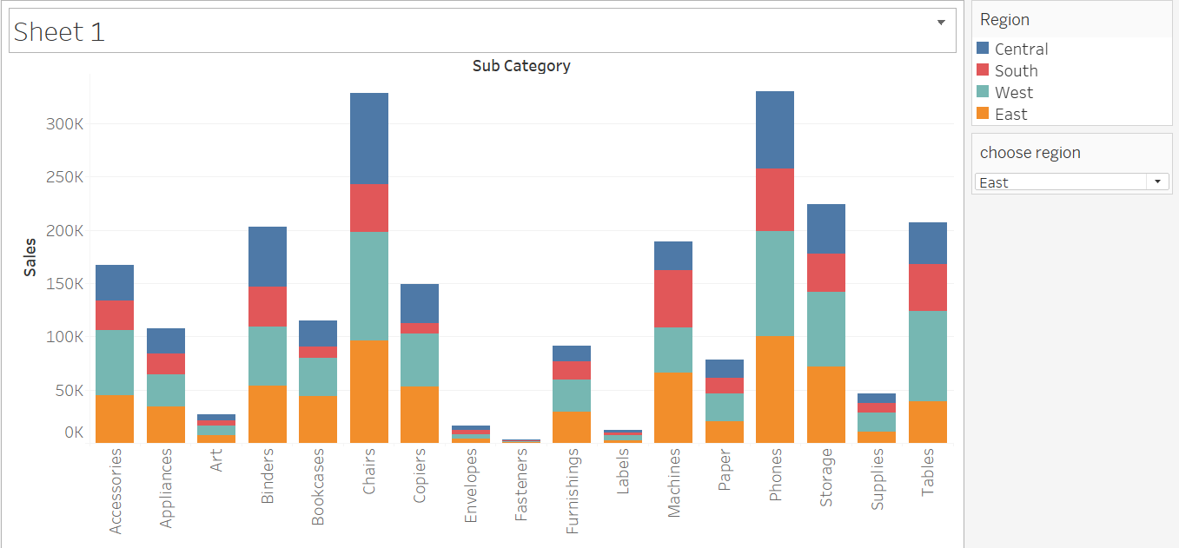

Choose region-> South(Red) -> at the bottom

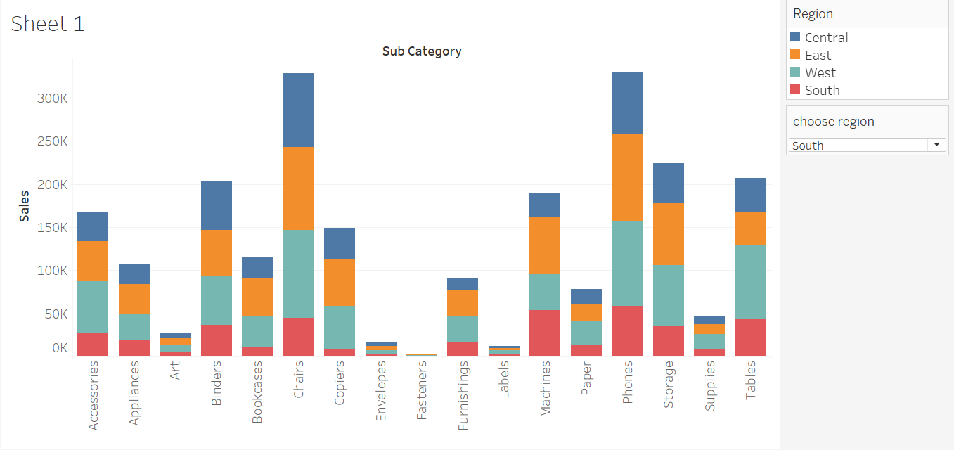

1. In the above chart make sure the sub category is sorted based on sales of the chosen region. So if user has chooses south then subcategories should be sorted based of south sales as below:

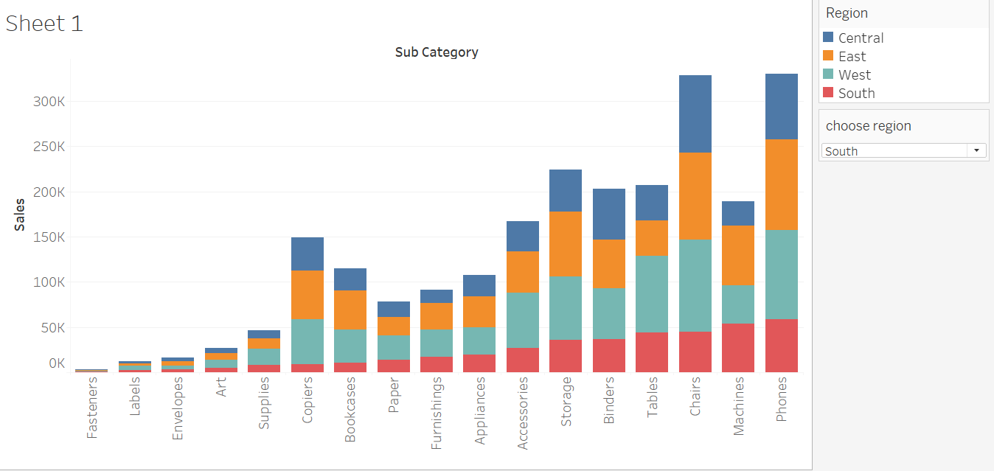

1. Create a lollipop chart for total sales for each sub category as below

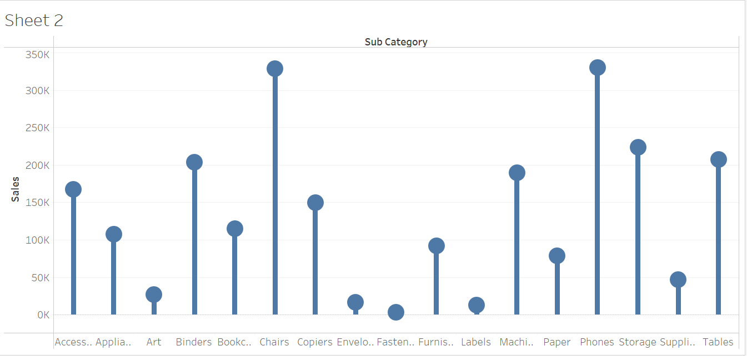

1. Create a dynamic chart which shows dimension and measures as per user input. There should be 2 parameters for choose dimension(region,state,category,segment), choose measure(sales,profit,quantity,no of records). If the user chooses region and profit then show total profit by region. Same should reflect as the chart title dynamically.
2. Create a line chart which shows total profit for each month/year. Based on below condition put a label on the line marks.

Profit < 0 then what the hell

Profit between 0 and 6000 then amazing

Profit > 6000 then Awesome

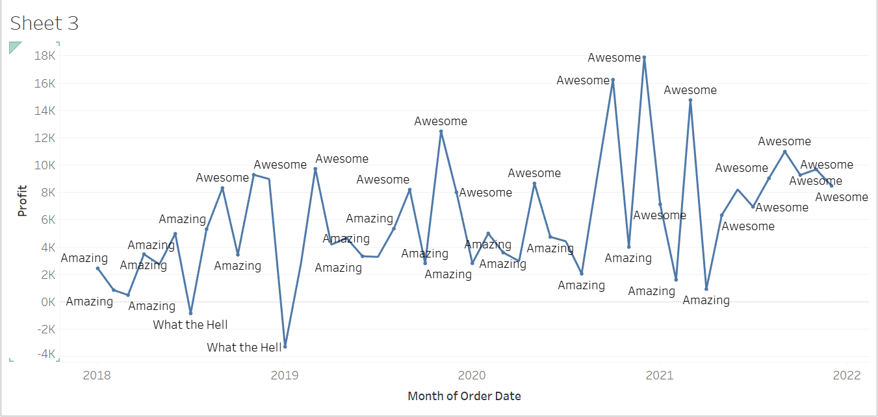

1. Create a dual axis chart as below. Makes sure the colour of the label is same as colour of the marks

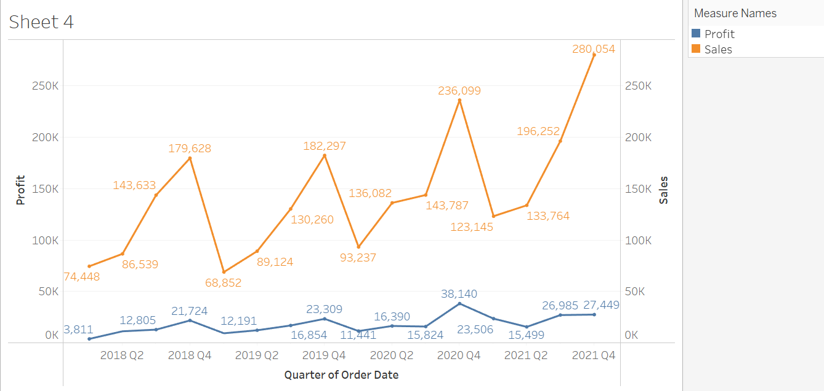

1. Create a sales view where users can select a specific year and quarter to view sales data product wise. Show the top 10 products for selected timeframe.
2. Allow users to analyze sales data over a custom date range. Create parameters to input Start Date, End Date by user. Show metrics such as total sales, total profit in a combined axis chart for selected date range.
3. Create chart which show sub category wise total sales. When you hover over each bar it should show month wise profit trends for that sub category as a viz on tooltip:

